for-word.jpgfor-word.jpg­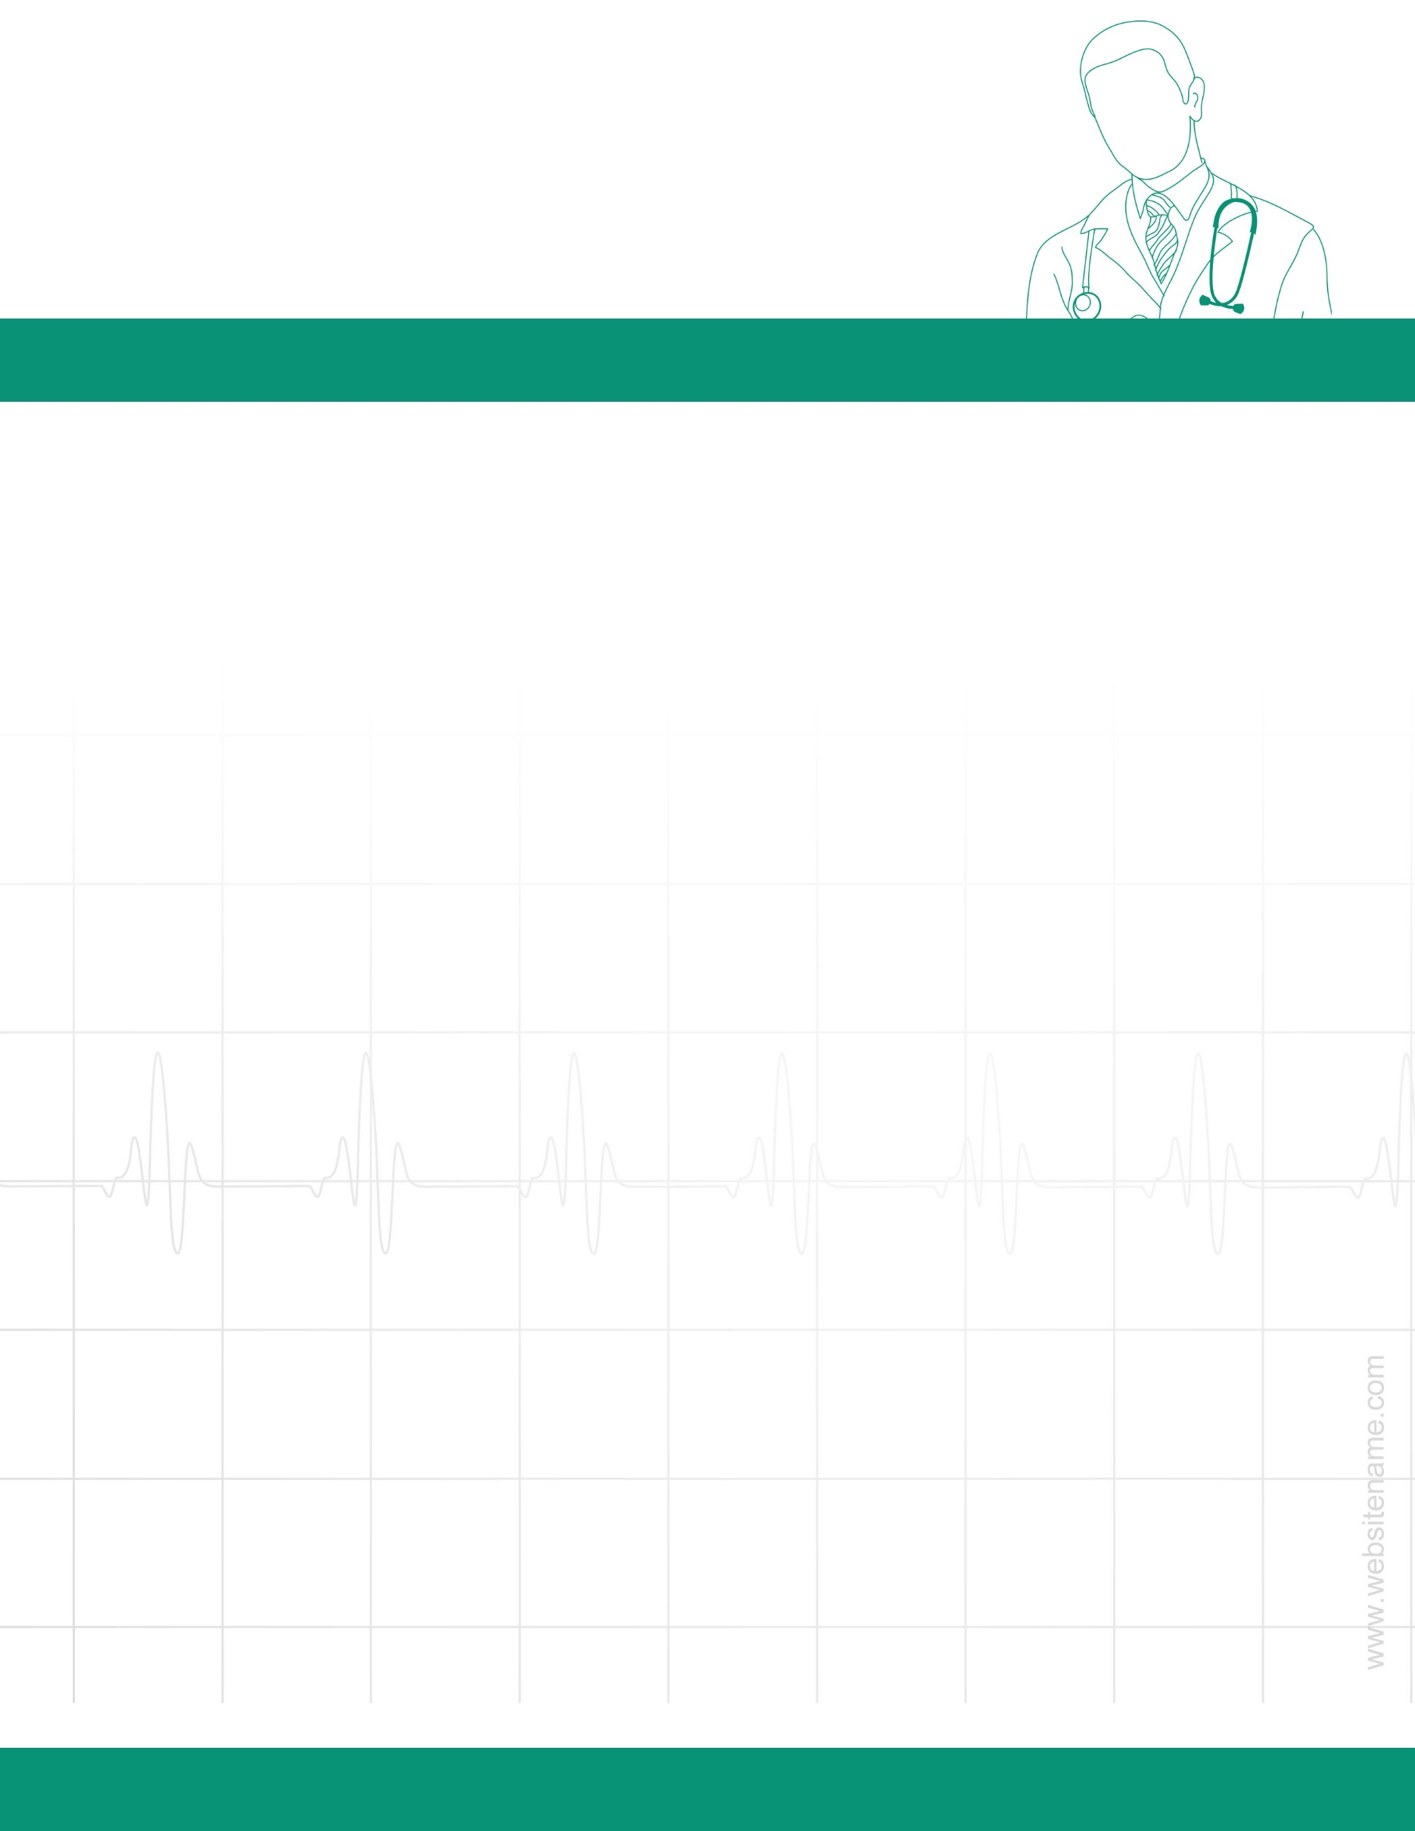

YOUR ADDRESS

CITY, STATE, ZIPCODE

name@mail.com

+92 551-456 9870

M.B.B.S, MS (SURG.) FAIS, FMAS

HOSPITAL NAME

DR. LOREM IPSUM

Lorem ipsum dolor sit met connecter